**Provision EC2 instance with Lambda**

**==============================**

1. **Create an IAM Policy**

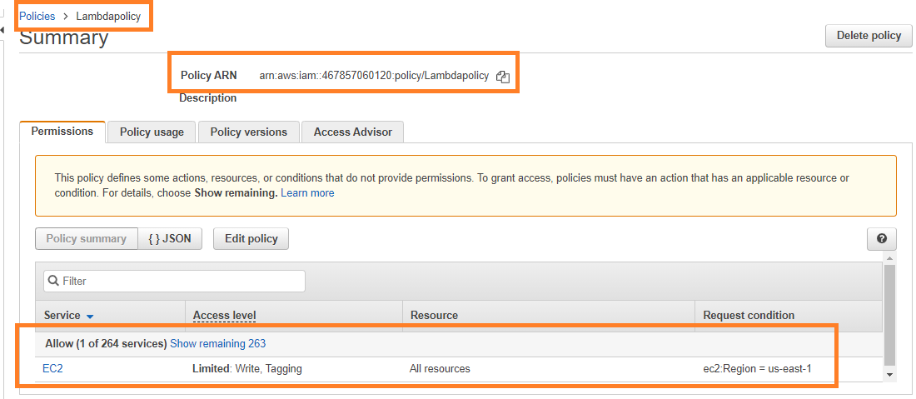

Fig. 1.1. Policy Dashboard

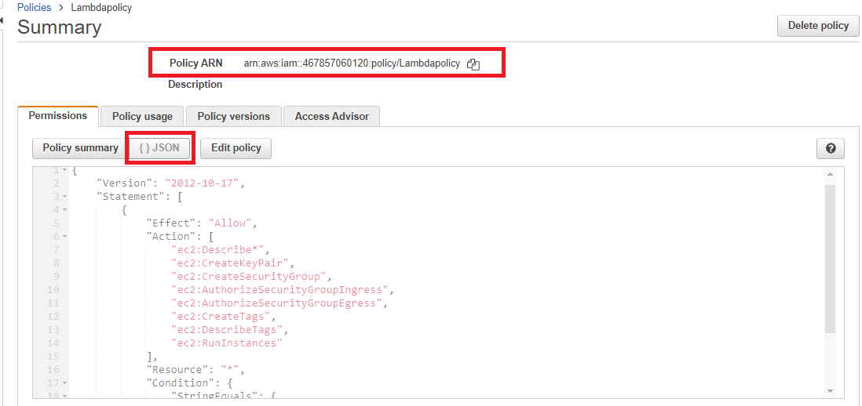

Fig. 1.2. Added JSON Policy

1. **Create an IAM Role**

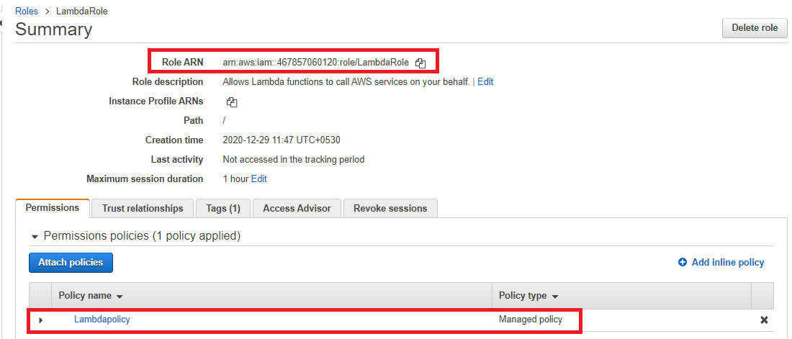

Fig. 2 Role for IAM

1. **Create a Lambda Function**

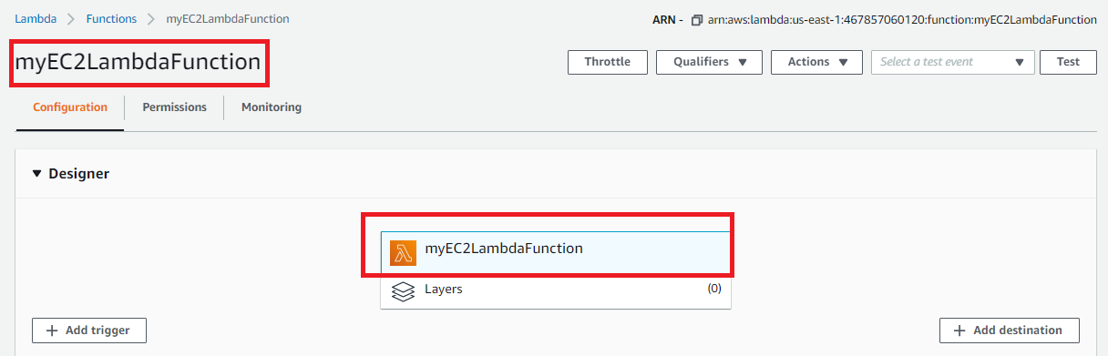

Fig. 3.1 Lambda function

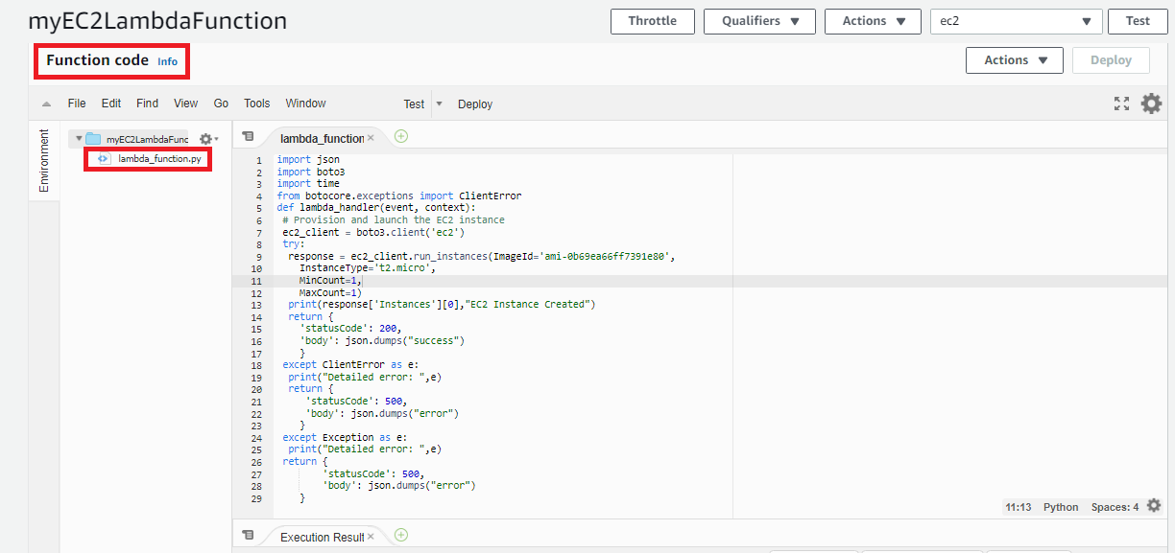

Fig. 3.2 python code

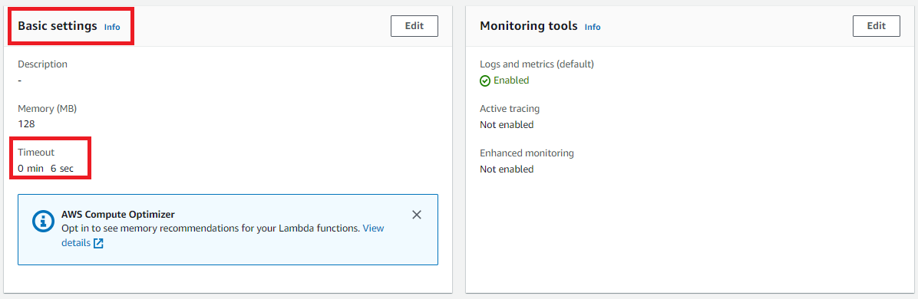

Fig. 3.3 Edited basic setting timeout

1. **Configure a Test Event**

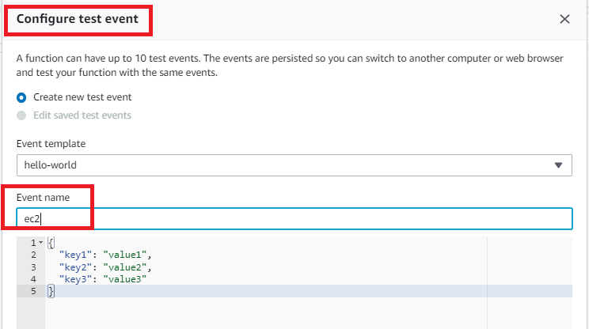

Fig. 4.1 Test event creation

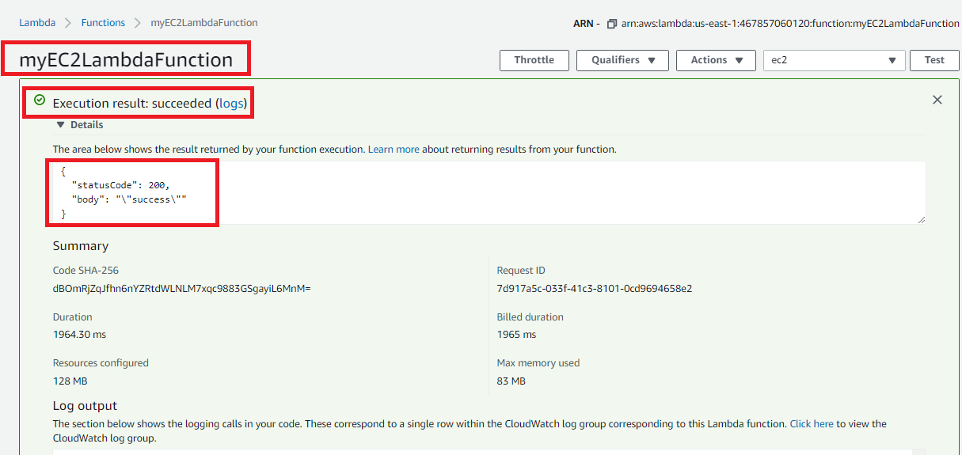

Fig. 4.2 Test event executed with successfully

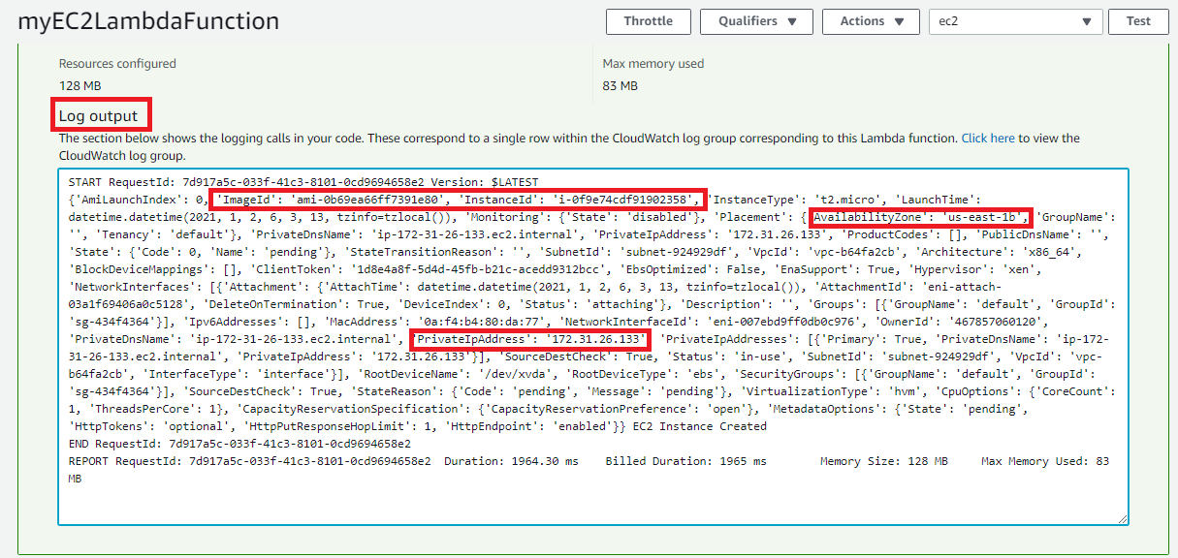

Fig. 4.3 Log output with details

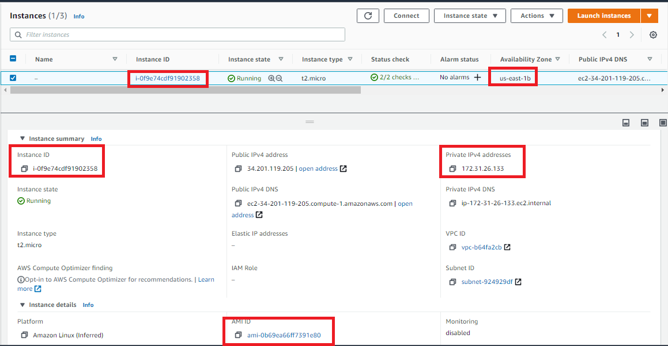

Fig. 4.4 Instance created